**1. INTRODUCTION**

**1.1. OBJECTIVE**

CLOUD Computing has been envisioned as the next generation information technology (IT) architecture for enterprises, due to its long list of unprecedented advantages in the IT history: on-demand self-service, ubiquitous network access, location independent resource pooling, rapid resource elasticity, usage-based pricing and transference of risk. As a disruptive technology with profound implications, Cloud Computing is transforming the very nature of how businesses use information technology. One fundamental aspect of this paradigm shifting is that data is being centralized or outsourced to the Cloud. From users’ perspective, including both individuals and IT enterprises, storing data remotely to the cloud in a flexible on-demand manner brings appealing benefits: relief of the burden for storage management, universal data access with location independence, and avoidance of capital expenditure on hardware, software, and personnel maintenances, etc.

**1.2. EXISTING SYSTEM**

While Cloud Computing makes these advantages more appealing than ever, it also brings new and challenging security threats towards users’ outsourced data. Since cloud service providers (CSP) are separate administrative entities, data outsourcing is actually relinquishing user’s ultimate control over the fate of their data. As a result, the correctness of the data in the cloud is being put at risk due to the following reasons. Although the infrastructures under the cloud are much more powerful and reliable than personal computing devices, they are still facing the broad range of both internal and external threats for data integrity. There do exist various motivations for CSP to behave unfaithfully towards the cloud users regarding their outsourced data status. For examples, CSP might reclaim storage for monetary reasons by discarding data that has not been or is rarely accessed, or even hide data loss incidents to maintain a reputation. In short, although outsourcing data to the cloud is economically attractive for long-term large-scale storage, it does not immediately offer any guarantee on data integrity and availability. This problem, if not properly addressed, may impede the success of cloud architecture.

As users no longer physically possess the storage of their data, traditional cryptographic primitives for the purpose of data security protection cannot be directly adopted. In particular, simply downloading all the data for its integrity verification is not a practical solution due to the expensiveness in I/O and transmission cost across the network. Besides, it is often insufficient to detect the data corruption only when accessing the data, as it does not give users correctness assurance for those unaccessed data and might be too late to recover the data loss or damage. Considering the large size of the outsourced data and the user’s constrained resource capability, the tasks of auditing the data correctness in a cloud environment can be formidable and expensive for the cloud users. Moreover, the overhead of using cloud storage should be minimized as much as possible, such that a user does not need to perform too many operations to use the data (in additional to retrieving the data). In particular, users may not want to go through the complexity in verifying the data integrity. Besides, there may be more than one user accesses the same cloud storage, say in an enterprise setting. For easier management, it is desirable that cloud only entertains verification request from a single designated party.

**1.2.1. DISADVANTAGES**

* Abuse and Nefarious Use of Cloud Computing

IaaS providers offer their customers the illusion of unlimited compute, network, and storage capacity often coupled with a ‘frictionless’ registration process where anyone with a valid credit card can register and immediately begin using cloud services. Some providers even offer free limited trial periods. By abusing the relative anonymity behind these registration and usage models, spammers, malicious code authors, and other criminals have been able to conduct their activities with relative impunity. PaaS providers have traditionally suffered most from this kind of attacks; however, recent evidence shows that hackers have begun to target IaaS vendors as well. Future areas of concern include password and key cracking, DDOS, launching dynamic attack points, hosting malicious data, botnet command and control, building rainbow tables, and CAPTCHA solving farms.

* Insecure Interfaces and APIs

Cloud Computing providers expose a set of software interfaces or APIs that customers use to manage and interact with cloud services. Provisioning, management, orchestration, and monitoring are all performed using these interfaces. The security and availability of general cloud services is dependent upon the security of these basic APIs. This introduces the complexity of the new layered API; it also increases risk, as organizations may be required to relinquish their credentials to third parties in order to enable their agency.

* Malicious Insiders

The threat of a malicious insider is well-known to most organizations. This threat is amplified for consumers of cloud services by the convergence of IT services and customers under a single management domain, combined with a general lack of transparency into provider process and procedure

* Shared Technology Issues

IaaS vendors deliver their services in a scalable way by sharing infrastructure. Often, the underlying components that make up this infrastructure were not designed to offer strong isolation properties for a multi-tenant architecture.

* Data Loss or Leakage

There are many ways to compromise data. Deletion or alteration of records without a backup of the original content is an obvious example

* Account or Service Hijacking

Account or service hijacking is not new. Attack methods such as phishing, fraud, and exploitation of software vulnerabilities still achieve results

* Unknown Risk Profile

. Security by obscurity may be low effort, but it can result in unknown exposures. It may also impair the in-depth analysis required highly controlled or regulated operational areas.

**1.3. PROPOSED SYSTEM**

The proposed system can be summarized as the following three aspects:

1) We motivate the public auditing system of data storage security in Cloud Computing and provide a privacy-preserving auditing protocol, i.e., our scheme supports an external auditor to audit user’s outsourced data in the cloud without learning knowledge on the data content.

2) To the best of our knowledge, our scheme is the first to support scalable and efficient public auditing in the Cloud Computing. In particular, our scheme achieves batch auditing where multiple delegated auditing tasks from different users can be performed simultaneously by the TPA.

3) We prove the security and justify the performance of our proposed schemes through concrete experiments and comparisons with the state-of-the-art.

**1.3.1. ADVANTAGES**

* Novel automatic and enforceable logging mechanism in the cloud.
* Proposed architecture is platform independent and highly decentralized, in that it does not require any dedicated authentication or storage system in place.
* Provide a certain degree of usage control for the protected data after these are delivered to the receiver
* The results demonstrate the efficiency, scalability, and granularity of our approach. We also provide a detailed security analysis and discuss the reliability and strength of our architecture.

**2. REQUIREMENT & ANALYSIS**

The software requirement specification gives the system specification in which process requirements are presented in an easily understandable way. Thus it contains all the inputs required, processes in the system and outputs produced by the system.

Software Requirements Specification plays an important role in creating quality software solutions. Specification is basically a representation process. Requirements are represented in a manner that ultimately leads to successful software implementation.

Requirements may be specified in a variety of ways. However there are some guidelines worth following

* Representation format and content should be relevant to the problem.
* Information contained within the specification should be nested.

Requirement analysis enables the system engineer to specify software function and perform, indicate software’s interface with the other system elements, and establish constraints that software must meet. Requirement analysis allows the analyst to refine the software allocation and build models of the data, functional and behavioral domains that will be treated by software.

The first step is to understand the user’s requirement within the framework of the organization’s objectives and the environment in which the system is installed. Considerations are given to the user to carry on with the work within the organization’s specified objectives.

Using swings in java we will develop the proposed system. The proposed application can be implemented by taking minimum of three systems into consideration. The server is implemented in one system TPA is implemented in another system and client can be implemented from n no of systems it can be implemented on any operating system like windows or linux. The client system will store data like files images on to server through TPA. The TPA will store the metadata information of file on TPA where as server will store files as well as metadata data information about the files. Whenever the client asks for the verification of files on cloud the TPA will check for the data integrity on the server. This application demands minimum three systems should be connected within a network.

**2.1 HARDWARE AND SOFTWARE REQUIREMENTS**

* Server and Client Side Technology : AWT and Swings.
* Database : MySQL
* Operating System : Windows95/98/2000/XP
* Processor : Pentium 4 processor
* RAM : 1 GB RAM
* Hard Disk : 80 GB Hard Disk Space

**2.2. ANALYSIS**

Analysis is logical process. The objective of this phase is to determine exactly what must be done to solve the problem. The activities in this phase include the investigation of the problem, the determination of the desired system performance.

Requirement analysis is the process of defining out what the user requires from the system to be developed and defining the requirements of the system in a clear and unambiguous way. The outcome of the requirement analysis is the software developing activity. Thus it deals with understanding the probe, the goals and constraints. The specification part mainly focuses on what has been found during analysis of the requirements.

The basic aim of this stage is to obtain a clear picture of the needs and requirements of the end-user and also the organization. Analysis involves interaction between the clients and the analysis. Usually analysts research a problem from any questions asked and reading.

FUNCTIONAL REQUIREMENTS

existing documents. The analysts have to uncover the real needs of the user even if they don’t know them clearly. During analysis it is essential that a complete and consistent set of specifications emerge for the system. Here it is essential to resolve the contradictions that could emerge from information got from various parties.

Functional requirements specify which output file should be produced from the given file they describe the relationship between the input and output of the system, for each functional requirement a detailed description of all data inputs and their source and the range of valid inputs must be specified.

NON FUNCTIONAL REQUIREMENTS

Describe user-visible aspects of the system that are not directly related with the functional behavior of the system. Non-Functional requirements include quantitative constraints, such as response time (i.e. how fast the system reacts to user commands.) or accuracy ((.e. how precise are the systems numerical answers.

PSEUDO REQUIREMENTS

The client that restricts the implementation of the system imposes these requirements. Typical pseudo requirements are the implementation language and the platform on which the system is to be implemented. These have usually no direct effect on the users view of the system**.**

PERFORMANCE REQUIREMENTS

Performance is measured in terms of the output provided by the application. Requirement specification plays an important part in the analysis of a system. Only when the requirement specifications are properly given, it is possible to design a system, which will fit into required environment. This is because the requirements have to be known during the initial stages so that the system can be designed according to those requirements. It is very difficult to change the system once it has been designed and on the other hand designing a system, which does not cater to the requirements of the user, is of no use.

The requirement specification for any system can be broadly stated as given below

* The system should be able to interface with the existing system
* The system should be accurate
* The system should be better than the existing system

**2.2.1. ABSTRACT**

Cloud computing (‘cloud’) is an evolving term that describes the development of many existing technologies and approaches to computing into something different. Cloud separates application and information resources from the underlying infrastructure, and the mechanisms used to deliver them.

Cloud enhances collaboration, agility, scaling, and availability, and provides the potential for cost reduction through optimized and efficient computing.

More specifically, cloud describes the use of a collection of services, applications, information, and infrastructure comprised of pools of compute, network, information, and storage resources. These components can be rapidly orchestrated, provisioned, implemented and decommissioned, and scaled up or down; providing for an on-demand utility-like model of allocation and consumption.

From an architectural perspective; there is much confusion surrounding how cloud is both similar to and different from existing models of computing; and how these similarities and differences impact the organizational, operational, and technological approaches to network and information security practices.

There are many definitions today which attempt to address cloud from the perspective of academicians, architects, engineers, developers, managers, and consumers. This document focuses on a definition that is specifically tailored to the unique perspectives of IT network and security professionals.

The keys to understanding how cloud architecture impacts security architecture are a common and concise lexicon, coupled with a consistent taxonomy of offerings by which cloud services and architecture can be deconstructed, mapped to a model of compensating security and operational controls, risk assessment and management frameworks, and in turn to compliance standards.

**2.2.2. ARCHITECTURE**



**Fig.No.2.1** Architecture Of Privacy Preserving Public Auditing For Secure Data Storage In Cloud

We consider a cloud data storage service involving three different entities, as illustrated in Fig. 4.1: the cloud user, who has large amount of data files to be stored in the cloud; the cloud server (CS), which is managed by the cloud service provider (CSP) to provide data storage service and has significant storage space and computation resources (we will not differentiate CS and CSP hereafter); the third party auditor (TPA), who has expertise and capabilities that cloud users do not have and is trusted to assess the cloud storage service reliability on behalf of the user upon request. Users rely on the CS for cloud data storage and maintenance. They may also dynamically interact with the CS to access and update their stored data for various application purposes. As users no longer possess their data locally, it is of critical importance for users to ensure that their data are being correctly stored and maintained. To save the computation resource as well as the online burden potentially brought by the periodic storage correctness verification, cloud users may resort to TPA for ensuring the storage integrity of their outsourced data, while hoping to keep their data private from TPA.

We assume the data integrity threats towards users’ data can come from both internal and external attacks at CS. These may include: software bugs, hardware failures, bugs in the network path, economically motivated hackers, malicious or accidental management errors, etc. Besides, CS can be self-interested. For their own benefits, such as to maintain reputation, CS might even decide to hide these data corruption incidents to users. Using third-party auditing service provides a cost-effective method for users to gain trust in Cloud. We assume the TPA, who is in the business of auditing, is reliable and independent. However, it may harm the user if the TPA could learn the outsourced data after the audit.

Note that in our model, beyond users’ reluctance to leak data to TPA, we also assume that cloud servers have no incentives to reveal their hosted data to external parties. On the one hand, there are regulations, e.g. HIPAA requesting CS to maintain users’ data privacy. On the other hand, as users’ data belong to their business asset, there also exist financial incentives for CS to protect it from any external parties. Therefore, we assume that neither CS nor TPA has motivations to collude with each other during the auditing process. In other words, neither entities will deviate from the prescribed protocol execution in the following presentation.

To authorize the CS to respond to the audit delegated to TPA’s, the user can issue a certificate on TPA’s public key, and all audits from the TPA are authenticated against such a certificate. These authentication handshakes are omitted in the following presentation.

**3. SYSTEM STUDY**

**3.1 FEASIBILITY STUDY**

Before development of any system or project and after understanding the problem, system study is conducted to learn the details of the current business situation. Information collected through the system study will be recorded in it. This serve as the basis for creating alternative design strategies. Only after the collected facts related to system or project is checked one can begin to determine how and when a computer information system can benefit all the users of system.

This accumulation of information, called a system study, must precede all the other system analysis activities. Information gathered through the study forms the basis for creating alternative design strategies. An important outcome of the preliminary investigation is the determination that the system requested is feasible. By seeing the initial statement we can identify scope and objective of the system and any constraints imposed on the system are identified. There are three aspects of feasibility study portion of preliminary investigation.

These three tests of feasibility are equally important they are

* Technical feasibility
* Operational feasibility
* Economical feasibility

The feasibility study is carried out by a small group of people who are familiar with formation system techniques, understand the part of the business organization that will be involved or affected by the project or system, and are skilled in the systems analysis and design process.

3.1.1. TECHNICAL FEASIBILITY

This application in going to be used in an network environment . So, it is necessary to use a technology that is capable of providing the networking facility to the application. We can deploy and used it in any operating system. This would also utilize very less system resources. This would use Windows OS (Preferably windows XP/2000). No much of the hardware configuration is required; a 512 MB RAM is quiet enough. Thus we can say that this solution is technically quite feasible.

The application is developed using swings in java. We can implement this application using a single system as it is a desktop application or we can implement it in a network by taking server as one system TPA as one system and client from n number of systems.

3.1.2. OPERATIONAL FEASIBILITY

This application is implemented using network Environment. The user should be aware of network in order to implement this application. The User can facilitate three systems like server, TPA, client using a single stand alone system as this is a standalone application.

3.1.3. ECONOMICAL FEASIBILITY

Economic analysis is the most frequently used technique for evaluating the effectiveness of a proposed system. It is more commonly known as cost/benefit analysis. The procedure is to determine the benefits and savings that are expected from a proposed system and compare them with costs. If benefits outweigh cost, a decision is taken to design and implement the system.

**3.2. TECHNOLOGIES USED**

**3.2.1. CLOUD COMPUTING**

Cloud computing is a model for enabling ubiquitous, convenient, on-demand network access to a shared pool of configurable computing resources (e.g., networks, servers, storage, applications, and services) that can be rapidly provisioned and released with minimal management effort or service provider interaction. This cloud model is composed of five essential characteristics**,** three service models, and four deployment models.

WHAT IS CLOUD COMPUTING?

Cloud computing (‘cloud’) is an evolving term that describes the development of many existing technologies and approaches to computing into something different. Cloud separates application and information resources from the underlying infrastructure, and the mechanisms used to deliver them.

Cloud enhances collaboration, agility, scaling, and availability, and provides the potential for cost reduction through optimized and efficient computing.

More specifically, cloud describes the use of a collection of services, applications, information, and infrastructure comprised of pools of compute, network, information, and storage resources. These components can be rapidly orchestrated, provisioned, implemented and decommissioned, and scaled up or down; providing for an on-demand utility-like model of allocation and consumption.

From an architectural perspective; there is much confusion surrounding how cloud is both similar to and different from existing models of computing; and how these similarities and differences impact the organizational, operational, and technological approaches to network and information security practices.

There are many definitions today which attempt to address cloud from the perspective of academicians, architects, engineers, developers, managers, and consumers. This document focuses on a definition that is specifically tailored to the unique perspectives of IT network and security professionals.

The keys to understanding how cloud architecture impacts security architecture are a common and concise lexicon, coupled with a consistent taxonomy of offerings by which cloud services and architecture can be deconstructed, mapped to a model of compensating security and operational controls, risk assessment and management frameworks, and in turn to compliance standards.

WHAT COMPRISES CLOUD COMPUTING?

The earlier version of the Cloud Security Alliance’s guidance featured definitions that were written prior to the published work of the scientists at the U.S. National Institute of Standards and Technology (NIST) and their efforts around defining cloud computing.

NIST’s publication is generally well accepted, and we have chosen to align with the NIST Working Definition of cloud computing (version 15 as of this writing) to bring coherence and consensus around a common language so we can focus on use cases rather than semantic nuance.

It is important to note that this guide is intended to be broadly usable and applicable to organizations globally. While NIST is a U.S. government organization, the selection of this reference model should not be interpreted to suggest the exclusion of other points of view or geographies.

NIST defines cloud computing by describing five essential characteristics, three cloud service models, and four cloud deployment models. They are summarized in visual form in figure 1 and explained in detail below.



Fig.3.1 NIST Visual Model of Cloud Computing Definition

**4. SYSTEM DESIGN**

**4.1. MODULES**

The system is proposed to have the following modules:

* Admin Module
* TPA module
* User Module
* Block Verification Module
* Block Insertion Module
* Block Deletion

4.1.1. ADMIN MODULE

Admin is allowed to check which user registered and which data is stored in the cloud space area

4.1.2. TPA MODULE

TPA check that data is modified or not if modified that information send to user

4.1.3. USER MODULE

User can register and he can login with his user id and password and he can upload the data to cloud space area

4.1.4. BLOCK VERIFICATION MODULE

User can check that the uploaded file is modified by any one or not (like server area)

4.1.5. BLOCK INSERTION MODULE

In the block insertion module user can insert the new block

4.1.6. BLOCK DELETION MODULE

In the Block Deletion Module user can delete the Block

**4.2. UMLS**

4.2.1. UNIFIED MODELING LANGUAGE

The Unified Modelling Language allows the software engineer to express an analysis model using the modelling notation that is governed by a set of syntactic semantic and pragmatic rules.

A UML system is represented using five different views that describe the system from distinctly different perspective. Each view is defined by a set of diagram, which is as follows.

* User Model View
* This view represents the system from the user's perspective.
* The analysis representation describes a usage scenario from the end-users perspective.
* Structural model view
* In this model the data and functionality are arrived from inside the system.
* This model view models the static structures.
* Behavioral Model View

It represents the dynamic of behavioral as parts of the system, depicting the interactions of collection between various structural elements described in the user model and structural model view.

* Implementation Model View

In this the structural and behavioral as parts of the system are represented as they are to be built.

* Environmental Model View

In this the structural and behavioral aspects of the environment in which the system is to be implemented are represented.

UML is specifically constructed through two different domains they are:

* UML Analysis modeling, this focuses on the user model and structural model views of the system.
* UML design modeling, which focuses on the behavioral modeling, implementation modeling and environmental model views.

Use case Diagrams represent the functionality of the system from a user’s point of view. Use cases are used during requirements elicitation and analysis to represent the functionality of the system. Use cases focus on the behaviour of the system from external point of view.

Actors are external entities that interact with the system. Examples of actors include users like administrator, bank customer …etc., or another system like central database.

4.2.1.1. CLASS DIAGRAM FOR PRIVACY PRESERVING PUBLIC AUDITING FOR SECURE DATA STORAGE IN CLOUD

This class diagram contains four classes that are Server, TPA, Client and Database. Server will perform operations like it maintains client details & session information stores details & files and generate graphs. Client will perform operations like registration, login, upload files,download files,verify documents,add blocks,delete blocks.TPA will perform operations like take file size, divide file into blocks, maintain metadata information, send response and verification message. And this diagram shows the relationship between this classes.



Fig 4.2: Class Diagram For Privacy Preserving Public Auditing For Secure Data Storage In Cloud

4.2.1.2. USECASE DIAGRAM FOR PRIVACY PRESERVING PUBLIC AUDITING FOR SECURE DATA STORAGE IN CLOUD

This usecase diagram contains three actors that are Server, TPA, Client and. Server will perform operations like it maintains client details & session information stores details & files and generate graphs. Client will perform operations like registration, login, upload files,download files,verify documents,add blocks,delete blocks.TPA will perform operations like take file size, divide file into blocks, maintain metadata information, send response and verification message. And this diagram shows the usecases of each actor and relationship between this actors and usecases.



Fig 4.3: Usecase Diagram For Privacy Preserving Public Auditing For Secure Data Storage In Cloud

4.2.1.3. SEQUENCE DIAGRAM FOR PRIVACY PRESERVING PUBLIC AUDITING FOR SECURE DATA STORAGE IN CLOUD

This sequence diagram contains three objects that are Server, TPA, Client and. Server will perform operations like it maintains client details & session information stores details & files and generate graphs. Client will perform operations like registration, login, upload files,download files,verify documents,add blocks,delete blocks.TPA will perform operations like take file size, divide file into blocks, maintain metadata information, send response and verification message. And this diagram shows the sequence of actions performed between these objects.



Fig 4.4: Sequence diagram For Privacy Preserving Public Auditing For Secure Data Storage In Cloud

4.2.1.4. COMPONENT DIAGRAM FOR PRIVACY PRESERVING PUBLIC AUDITING FOR SECURE DATA STORAGE IN CLOUD

This component diagram contains three components that are Server, TPA, Client and. Server will perform operations like it maintains client details & session information stores details & files and generate graphs. Client will perform operations like registration, login, upload files,download files,verify documents,add blocks,delete blocks.TPA will perform operations like take file size, divide file into blocks, maintain metadata information, send response and verification message. And this diagram shows the actions performed by these components.



Fig 4.5: Component diagram For Privacy Preserving Public Auditing For Secure Data Storage In Cloud

4.2.1.5. DEPLOYMENT DIAGRAM FOR PRIVACY PRESERVING PUBLIC AUDITING FOR SECURE DATA STORAGE IN CLOUD

This deployment diagram contains three nodes that are Server, TPA, Client and. Server will perform operations like it maintains client details & session information stores details & files and generate graphs. Client will perform operations like registration, login, upload files,download files,verify documents,add blocks,delete blocks.TPA will perform operations like take file size, divide file into blocks, maintain metadata information, send response and verification message. And this diagram shows the communication between these nodes.



Fig 4.6: Deployment diagram For Privacy Preserving Public Auditing For Secure Data Storage In Cloud

4.2.1.6. ACTIVITY DIAGRAM FOR PRIVACY PRESERVING PUBLIC AUDITING FOR SECURE DATA STORAGE IN CLOUD

This activity diagram contains three activities that are Server, TPA, Client and. This diagram shows the flow of control between these activities.

**Start**

Download File

Upload File

Login

User

Divide into blocks

TPA

**End**

Modify data

Server will send verification details

**End**

Fig 4.7: Activity diagram For Privacy Preserving Public Auditing For Secure Data Storage In Cloud

4.2.1.7 CLASS DIAGRAM FOR PRIVACY PRESERVING PUBLIC AUDITING FOR SECURE DATA STORAGE ON CLOUD

An object diagram focuses on some particular set of objects and attributes, and the links between these instances. A correlated set of object diagrams provides insight into how an arbitrary view of a system is expected to evolve over time. In early UML specifications the object diagram is described as:



**Fig**: 4.8 object diagram for privacy preserving public auditing for secure data storage on cloud

**4.3.DATABASE DESIGN**

A Database is a collection of interrelated data stored with a minimum of redundancy to serve many applications. The database design is used to group data into a number of tables and minimizes the artificiality embedded in using separate files. The tables are organized to:

* Reduced duplication of data.
* Simplify functions like adding, deleting, modifying data etc..,
* Retrieving data
* Clarity and ease of use
* More information at low cost

# 4.3.1. NORMALIZATION

Normalization is built around the concept of normal forms. A relation is said to be in a particular normal form if it satisfies a certain specified set of constraints on the kind of functional dependencies that could be associated with the relation. The normal forms are used to ensure that various types of anomalies and inconsistencies are not introduced into the database.

4.3.1.1. FIRST NORMAL FORM

A relation R is in first normal form if and only if all underlying domains contained atomic values only.

4.3.1.2. SECOND NORMAL FORM

A relation R is said to be in second normal form if and only if it is in first normal form and every non-key attribute is fully dependent on the primary key.

4.3.1.3. THIRD NORMAL FORM

A relation R is said to be in third normal form if and only if it is in second normal form and every non key attribute is non transitively depend on the primary key.

4.3.2. DATA DICTIONARY

create database audit;

use audit;

create table register(uname varchar(40),pass varchar(40),cpass varchar(40),contact varchar(12),email varchar(40));

**4.3.3. ER-DIAGRAMS**

This ER-Diagram contains three entities that are Server, TPA, Client and. Server will perform operations like it maintains client details & session information stores details & files and generate graphs. Client will perform operations like registration, login, upload files,download files,verify documents,add blocks,delete blocks.TPA will perform operations like take file size, divide file into blocks, maintain metadata information, send response and verification message. And this diagram shows the relationship between these entities.

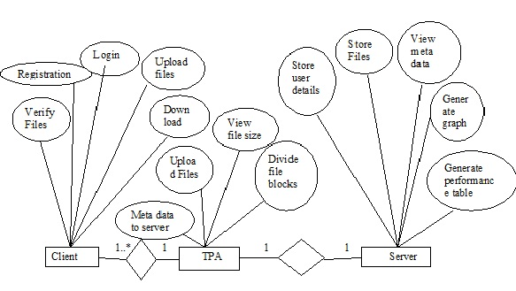

Fig 4.8: ER- Diagram For Privacy Preserving Public Auditing For Data Storage In Cloud

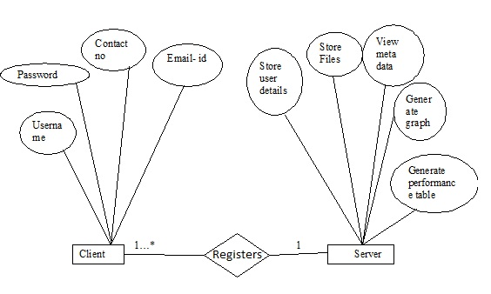

Fig 4.9: ER- Diagram For client registration

**5. IMPLEMENTATION**

**5.1. PROBLEM DEFINITION**

One of the biggest concerns with cloud data storage is that of data integrity verification at untrusted servers. The storage service provider for saving money and storage space the service provider might neglect to keep or delete rarely accessed data files which belong to an ordinary client.

**5.2. PROPOSED MODULES**

5.2.1. TPA

An entity, which has expertise and capabilities that clients do not have, is trusted to assess and expose risk of cloud storage services on behalf of the clients upon request.

5.2.2. PUBLIC AUDITABILITY

To allow TPA to verify the correctness of the cloud data on demand without Retrieving a copy of the whole data or introducing additional online burden to the cloud users.

5.2.3. PRIVACY-PRESERVING

To ensure that the TPA cannot derive users’ data content from the information collected during the auditing process.

5.2.3. BATCH AUDITING

To enable TPA with secure and efficient auditing capability to cope with multiple auditing delegations from possibly large number of different users simultaneously.

**5.3. WORKING PRINCIPLE**

STEP 1

The first is to initiate the server whenever the server is started automatically a folder named cloud will be created in the "D" drive because it is coded in such a way to create a folder named cloud in drive "D". The second step is to initiate the TPA whenever the TPA is initiated a folder named TPA will be created in "D" drive. The next is to initiate the client whenever the client is initiated user login and registration page will be displayed. If user wants to login he should be registered. For registration he should fill the registration form and click on submit when the submit button is clicked the user details will be stored into the server's database. When the registration is completed a folder will be created inside cloud folder in D drive because of the code

if(msg.equals("Registration completed")){

area.append("New user registration completed\n");

File file = new File("D:/Cloud/"+user[0].trim());

if(!file.exists())

file.mkdirs();

}

}

STEP 2

After registration user has to enter both login name and password of the user and click on login if username and valid user home page will be displayed. It contains options like "upload file", "download file", "verify file", "block insertion", " block deletion " and logout.

STEP 3

For uploading the file to the cloud user has to click on upload file button when the upload file button is clicked user can browse the files from the system and upload to the cloud. In this process TPA will store the metadata information of the file in particular user folder in TPA folder and message is displayed on the screen.

if(type.equals("upload")){

String user= input[2].toString().trim();

Object row[][]=(Object[][])input[1];

String fname=input[3].toString().trim();

delete(fname,user);

StringBuffer sb=new StringBuffer();

File file = new File("D:/TPA/"+user);

if(!file.exists())

file.mkdirs();

for(int i=0;i<row.length;i++){

String blockname=row[i][1].toString();

String signature=row[i][2].toString();

String length=row[i][3].toString();

name=row[i][4].toString();

sb.append(name+","+blockname+","+signature+","+length+System.getProperty("line.separator"));

area.append("Received File Metadata "+blockname+" Signature "+signature+" Size "+length+"\n");

}

FileWriter fw=new FileWriter("D:/TPA/"+user+"/metadata.txt",true);

fw.write(sb.toString());

fw.flush();

fw.close();

Object res[]={"Given file "+name+" metadata(signature) saved on TPA server"};

out.writeObject(res);

out.flush();

STEP 4

While storing the file at the server file is divided into blocks and that information is stored as metadata in the server.

if(type.equals("insert")){

byte b[]=(byte[])input[1];

String block = input[2].toString();

String signature = input[3].toString();

String length = input[4].toString();

String file = input[5].toString();

String user = input[6].toString();

String blockname = getBlockName(file,user);

FileOutputStream fout = new FileOutputStream("D:/Cloud/"+user+"/"+blockname);

fout.write(b,0,b.length);

fout.flush();

fout.close();

area.append("Received new File block "+blockname+"\n");

FileWriter fw=new FileWriter("D:/Cloud/"+user+"/metadata.txt",true);

fw.write(file+","+blockname+","+signature+","+length+System.getProperty("line.separator"));

fw.flush();

fw.close();

Object res[]={"Given file block"+blockname+" inserted on cloud server"};

out.writeObject(res);

out.flush();

}

STEP 5

When user wants to download documents from cloud user can select the file and download it to the system downloaded file will be stored in "D" drive.

FileOutputStream fout=new FileOutputStream("D:/"+file);

fout.write(b1,0,b1.length);

fout.flush();

fout.close();

And message is displayed on the screen as

area.append("Selected file downloaded in 'System D' directory\n");

STEP 6

Next step is to verify whether the file modified or not. This is checked using the code

if(files.length() != Long.parseLong(size[i].trim())){

flag=true;

break;

}

}

if(flag){

Object res[]={"Your file has been modified by the server"};

out.writeObject(res);

out.flush();

area.append(user+" file "+file+" modified\n");

}if(!flag){

Object res[]={"Your file has not been modified by the server"};

out.writeObject(res);

out.flush();

area.append(user+" file "+file+" not modified\n");

STEP 7

If user wants to insert block of file to already existing file user has to click on block insertion button then user can browse block of file to insert to the existing file. The code for this function is

if(type.equals("insert")){

byte b[]=(byte[])input[1];

String block = input[2].toString();

String signature = input[3].toString();

String length = input[4].toString();

String file = input[5].toString();

String user = input[6].toString();

String blockname = getBlockName(file,user);

FileOutputStream fout = new FileOutputStream("D:/Cloud/"+user+"/"+blockname);

fout.write(b,0,b.length);

fout.flush();

fout.close();

area.append("Received new File block "+blockname+"\n");

FileWriter fw=new FileWriter("D:/Cloud/"+user+"/metadata.txt",true);

fw.write(file+","+blockname+","+signature+","+length+System.getProperty("line.separator"));

fw.flush();

fw.close();

Object res[]={"Given file block"+blockname+" inserted on cloud server"};

out.writeObject(res);

out.flush();

}

STEP 8

If user wants to delete block of file from the existing files than user has to select the block of file and delete that particular block. for performing this function the code is

if(type.equals("deleteblock")){

String file= input[1].toString().trim();

String user= input[2].toString().trim();

StringBuffer sb=new StringBuffer();

BufferedReader br = new BufferedReader(new FileReader("D:/Cloud/"+user+"/metadata.txt"));

String line="";

while((line = br.readLine()) != null){

String s[]=line.trim().split(",");

if(!s[1].equals(file))

sb.append(line+System.getProperty("line.separator"));

}

br.close();

FileWriter fw=new FileWriter("D:/Cloud/"+user+"/metadata.txt");

fw.write(sb.toString());

fw.flush();

fw.close();

File file1=new File("D:/Cloud/"+user+"/"+file);

file1.delete();

Object res[]={"File Deleted"};

out.writeObject(res);

out.flush();

}

STEP 9

Next option for the user is logout. By clicking on this logout button the connection will be terminated between user and the server that means user will logout from the server. The operations performed by the user can be computed by the server and server can display the performance as charts. The server will display the system's performance in the form of comparison chart, auditing comparison chart, performance table.

STEP 10

Comparison chart will display the average auditing time of each client who is logged into the system. Auditing comparison chart will display auditing time for all the blocks. Auditing time for each block is compared in auditing comparison chart. Performance table will calculate the server computational time and verifier computational time of the system.

**6. TESTING**

Testing is vital to the success of the system. System testing makes a logical assumption that if all parts of the system are correct, the goal will be successfully achieved. In the testing process we test the actual system in an organization and gather errors from the new system operates in full efficiency as stated. System testing is the stage of implementation, which is aimed to ensuring that the system works accurately and efficiently.

In the testing process we test the actual system in an organization and gather errors from the new system and take initiatives to correct the same. All the front-end and back-end connectivity are tested to be sure that the new system operates in full efficiency as stated. System testing is the stage of implementation, which is aimed at ensuring that the system works accurately and efficiently.

The main objective of testing is to uncover errors from the system. For the uncovering process we have to give proper input data to the system. So we should have more conscious to give input data. It is important to give correct inputs to efficient testing.

Testing is done for each module. After testing all the modules, the modules are integrated and testing of the final system is done with the test data, specially designed to show that the system will operate successfully in all its aspects conditions. Thus the system testing is a confirmation that all is correct and an opportunity to show the user that the system works. Inadequate testing or non-testing leads to errors that may appear few months later.

The testing process focuses on logical intervals of the software ensuring that all the statements have been tested and on the function intervals (i.e.,) conducting tests to uncover errors and ensure that defined inputs will produce actual results that agree with the required results. Testing has to be done using the two common steps Unit testing and Integration testing. In the project system testing is made as follows:

The procedure level testing is made first. By giving improper inputs, the errors occurred are noted and eliminated. This is the final step in system life cycle. Here we implement the tested error-free system into real-life environment and make necessary changes, which runs in an online fashion. Here system maintenance is done every months or year based on company policies, and is checked for errors like runtime errors, long run errors and other maintenances like table verification and reports.

**6.1. TYPES OF TESTS**

6.1.1. UNIT TESTING

Unit testing involves the design of test cases that validate that the internal program logic is functioning properly, and that program inputs produce valid outputs. All decision branches and internal code flow should be validated. It is the testing of individual software units of the application; it is done after the completion of an individual unit before integration. This is a structural testing, that relies on knowledge of its construction and is invasive. Unit tests perform basic tests at component level and test a specific business process, application, and/or system configuration. Unit tests ensure that each unique path of a business process performs accurately to the documented specifications and contains clearly defined inputs and expected results.

Unit testing is usually conducted as part of a combined code and unit test phase of the software lifecycle, although it is not uncommon for coding and unit testing to be conducted as two distinct phases.

**6.1.1.1. TEST STRATEGY AND APPROACH**

Field testing will be performed manually and functional tests will be written in detail.

**6.1.1.2. TEST OBJECTIVES**

* All field entries must work properly.
* Pages must be activated from the identified link.
* The entry screen, messages and responses must not be delayed.

**6.1.1.3. FEATURES TO BE TESTED**

* Verify that the entries are of the correct format
* No duplicate entries should be allowed
* All links should take the user to the correct page.

6.1.2. INTEGRATION TESTING

Integration tests are designed to test integrated software components to determine if they actually run as one program. Testing is event driven and is more concerned with the basic outcome of screens or fields. Integration tests demonstrate that although the components were individually satisfaction, as shown by successfully unit testing, the combination of components is correct and consistent.

Integration testing is specifically aimed at exposing the problems that arise from the combination of components.

Software integration testing is the incremental integration testing of two or more integrated software components on a single platform to produce failures caused by interface defects.

The task of the integration test is to check that components or software applications, e.g. components in a software system or – one step up – software applications at the company level – interact without error.

**Test Results:**

All the test cases mentioned above passed successfully. No defects encountered.

6.1.3. **Functional testing**

This type of testing ignores the internal parts and focus on the output is as per requirement or not. Black-box type testing geared to functional requirements of an application.

6.1.4. BLACKBOX TESTING

Internal system design is not considered in this type of testing. Tests are based on requirements and functionality.

**6.1.5. WHITE BOX TESTING**

This testing is based on knowledge of the internal logic of an application’s code. Also known as Glass box Testing. Internal software and code working should be known for this type of testing. Tests are based on coverage of code statements, branches, paths, conditions.

**6.2. TESTCASES**

6.2.1. TEST CASE FOR USER REGISTRATION

|  |  |  |  |
| --- | --- | --- | --- |
| **Test Cases:** enter the details | | **Priority (H , L):** High | |
| **Test Objective:** User registration | | | |
| **Test Description:** User has to register before login to use the system | | | |
| **Actions** | | **Expected Results** | |
| The user will register in the cloud | | Registration should complete and message should be displayed as registration completed | |
| **Pass**: yes | **Conditions pass**: yes | | **Fail**: No |
| **Problems / Issues:** No | | | |
| **Notes:** Successfully completed | | | |

Fig: 6.1Testcase for user Registration

6.2.2 TEST CASE FOR PERFORMANCE TABLE:

|  |  |  |  |
| --- | --- | --- | --- |
| **Test Case :** Performance table | | **Priority (H , L): High** | |
| **Test Objective:** working of performance table | | | |
| **Test Description:**It calculates server and verifier computation time | | | |
| **Actions** | | **Expected Results** | |
| Server and verifier computation time is calculated and displayed in the table | | Server and verifier computation time is to be calculated and displayed in table | |
| **Pass: Yes** | **Conditions pass:** Yes | | **Fail:** No |
| **Problems / Issues:** No | | | |
| **Notes:** Successfully executed | | | |

**Fig:** 6.2 Test case for performance table

**7. SCREENS**

The below screen shows that server is initiated so that the cloud is ready for storing data that can be files images etc.

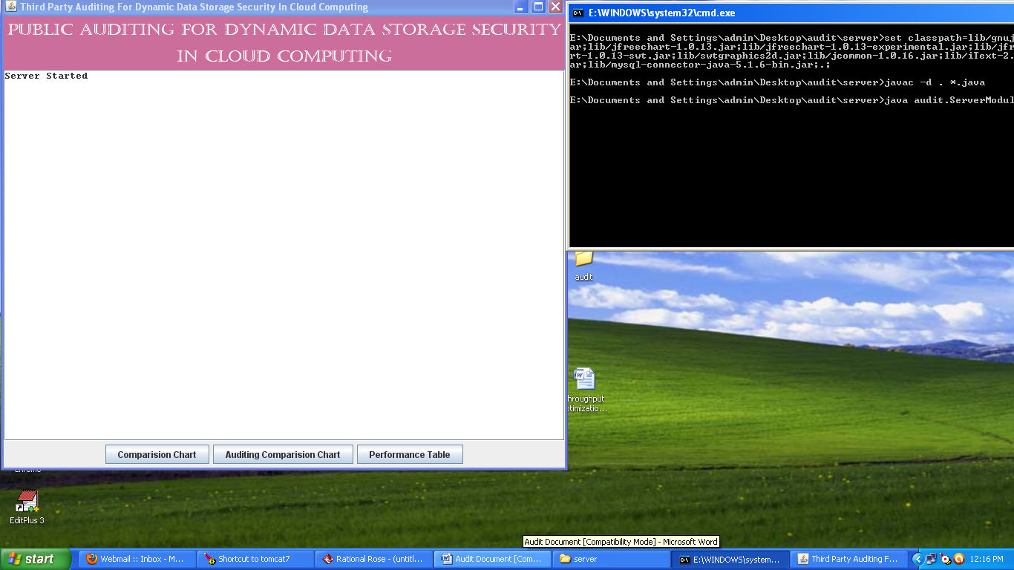

Fig 7.1 Server is Started

The below screen shows that TPA is initiated so that it can perform it actions like checking data integrity of outsourced data by the user.

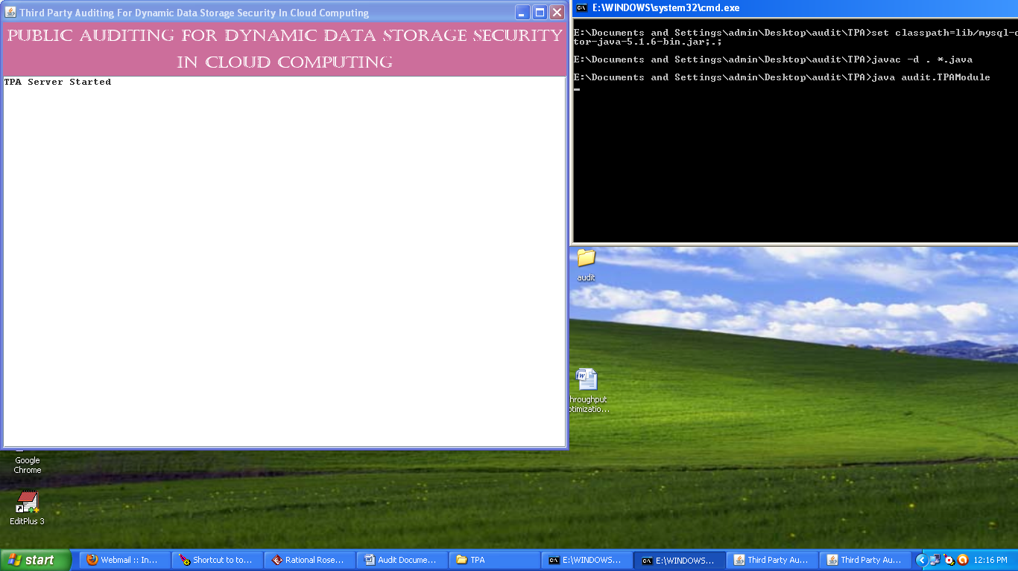

Fig 7.2 TPA Module is Started

The below screen shows the client page of the user using this page registered users can login by clicking on login button where as non registered users can go to registration page by clicking on the registration button.

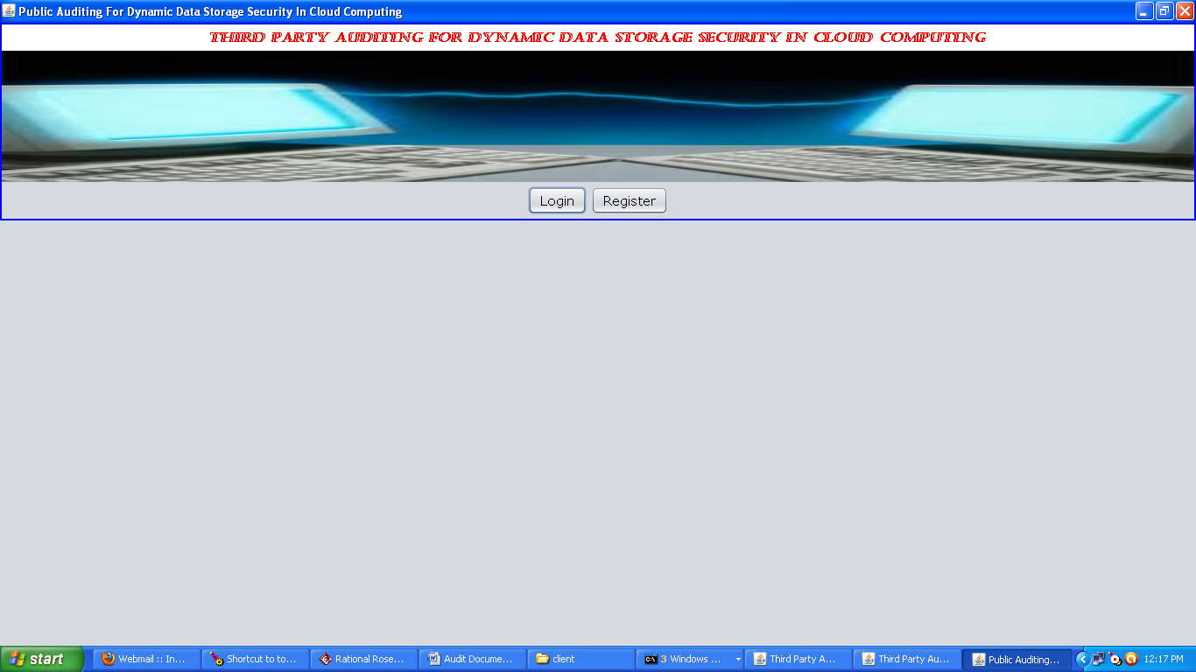

Fig 7.3 Client Screen

The below screen displays the registration page for the non registered users this page contains fields like username, password, conform password, contact no, email-id etc. After entering all the field’s user should click on register button to conform the registration.

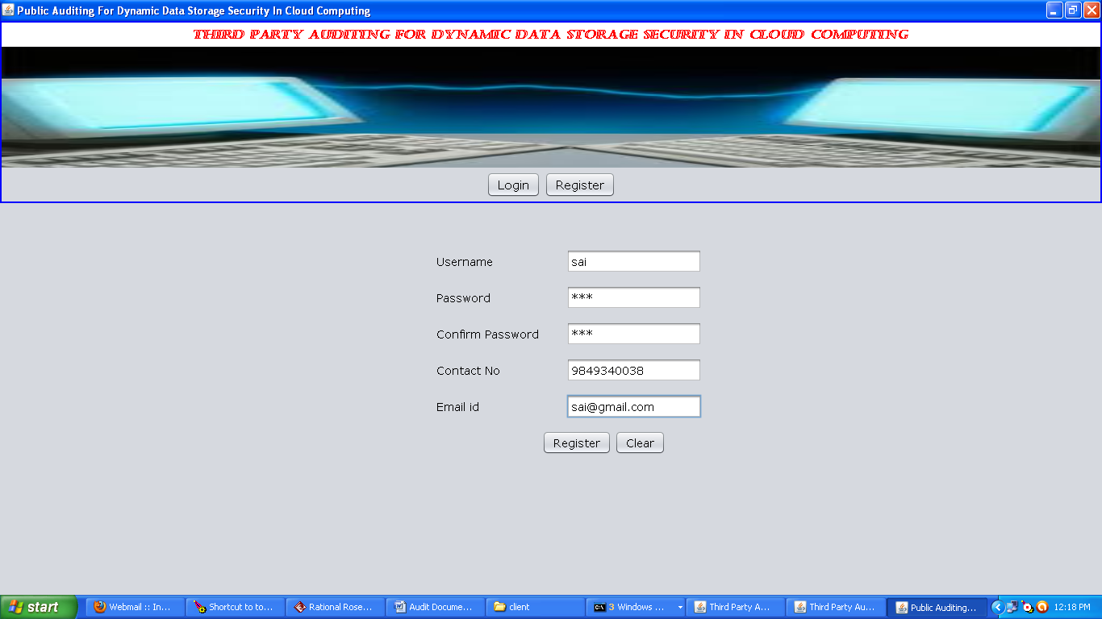

Fig 7.4 Registration Page

The below screen shows the login page of the user here user can login by entering the fields like username and password and clicking on the login button. Here clear button is used for clearing the field like username and password.

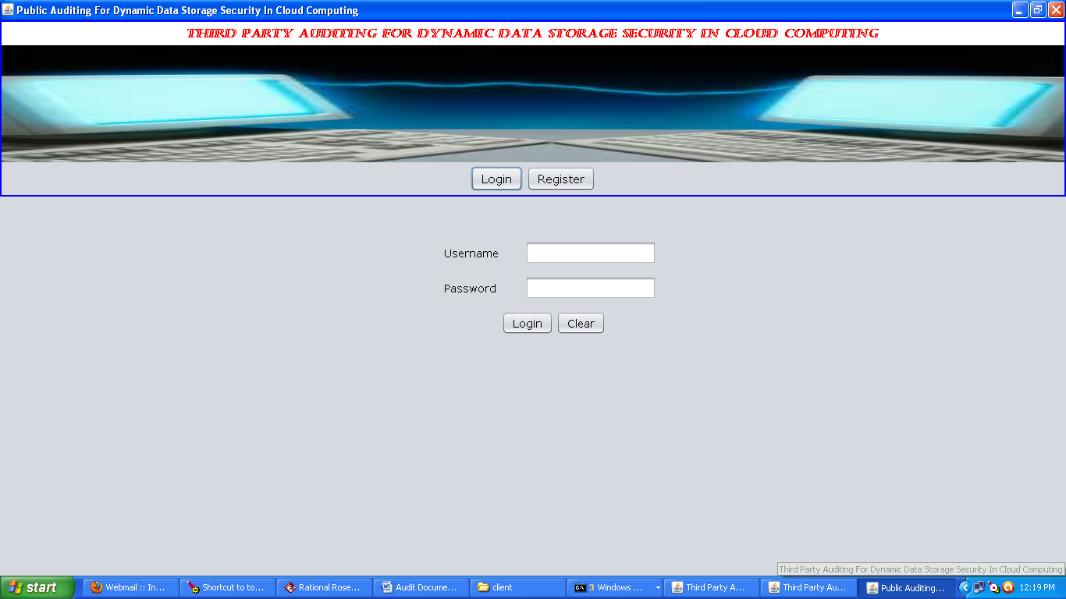

Fig 7.5 Client Login Page

The below screen shows the home page of the client after login he can perform operations like uploading the documents, downloading the documents, verifying the documents, block insertion, block deletion, and logout.

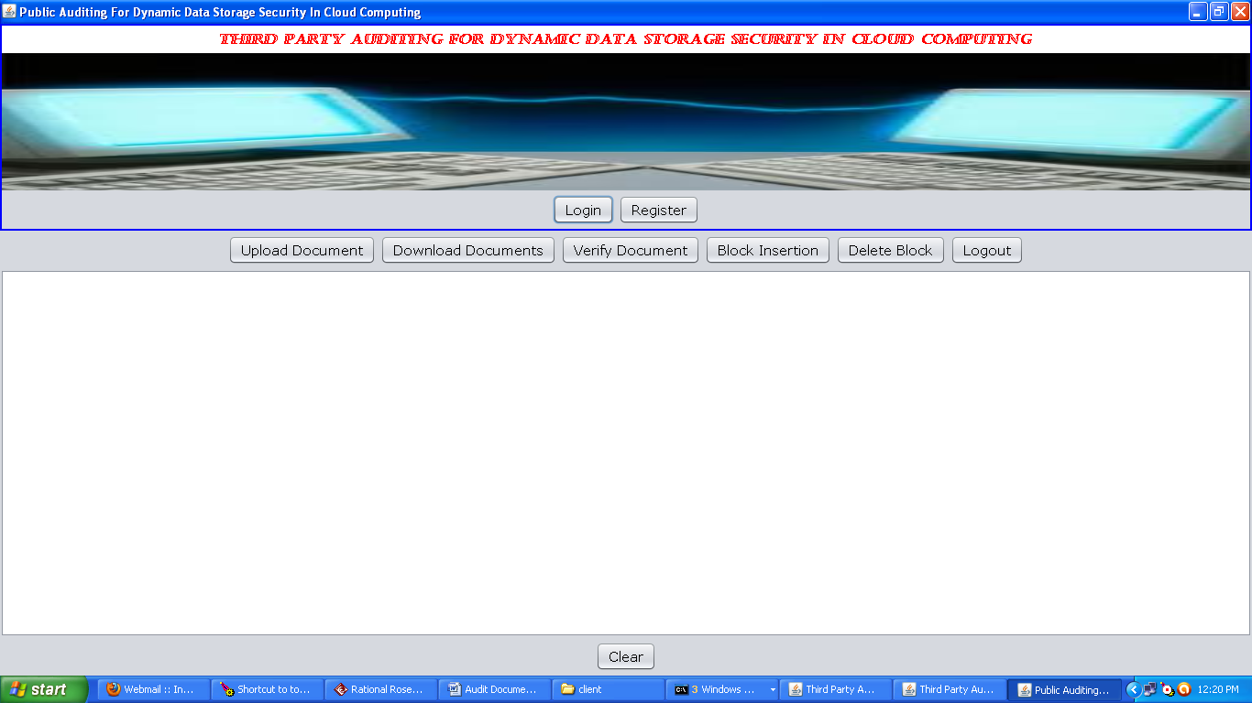

Fig 7.6 Client Page

The below screen shows uploading the documents from computer to the cloud whenever the user clicks on the upload document button he can browse the file in the system and upload them them to cloud by clicking on the open button in the below screen if he want to cancel the operation he can click on cancel button shown in the screen.

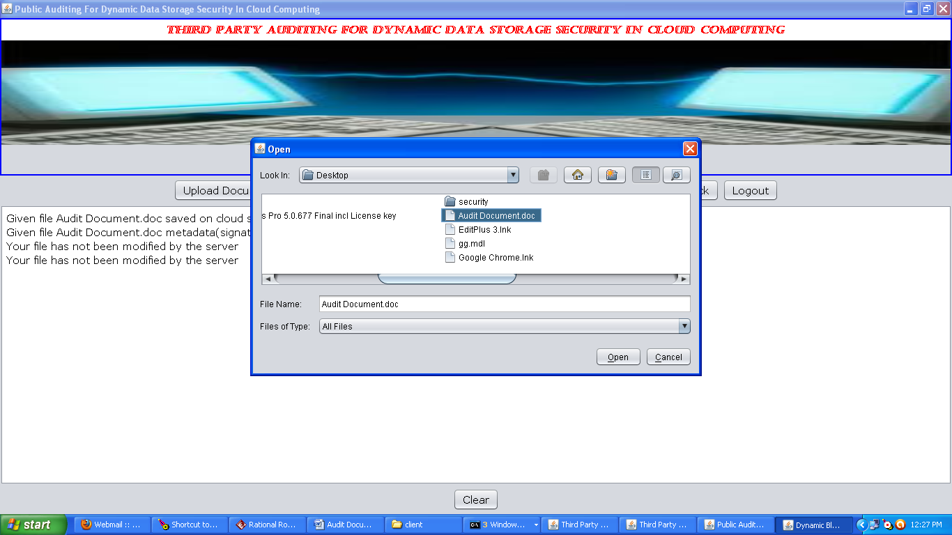

Fig 7.7 Upload File Page

After uploading the file to the cloud the message is displayed on the client page as particular file is stored on the cloud server and particular file metadata saved on TPA server.

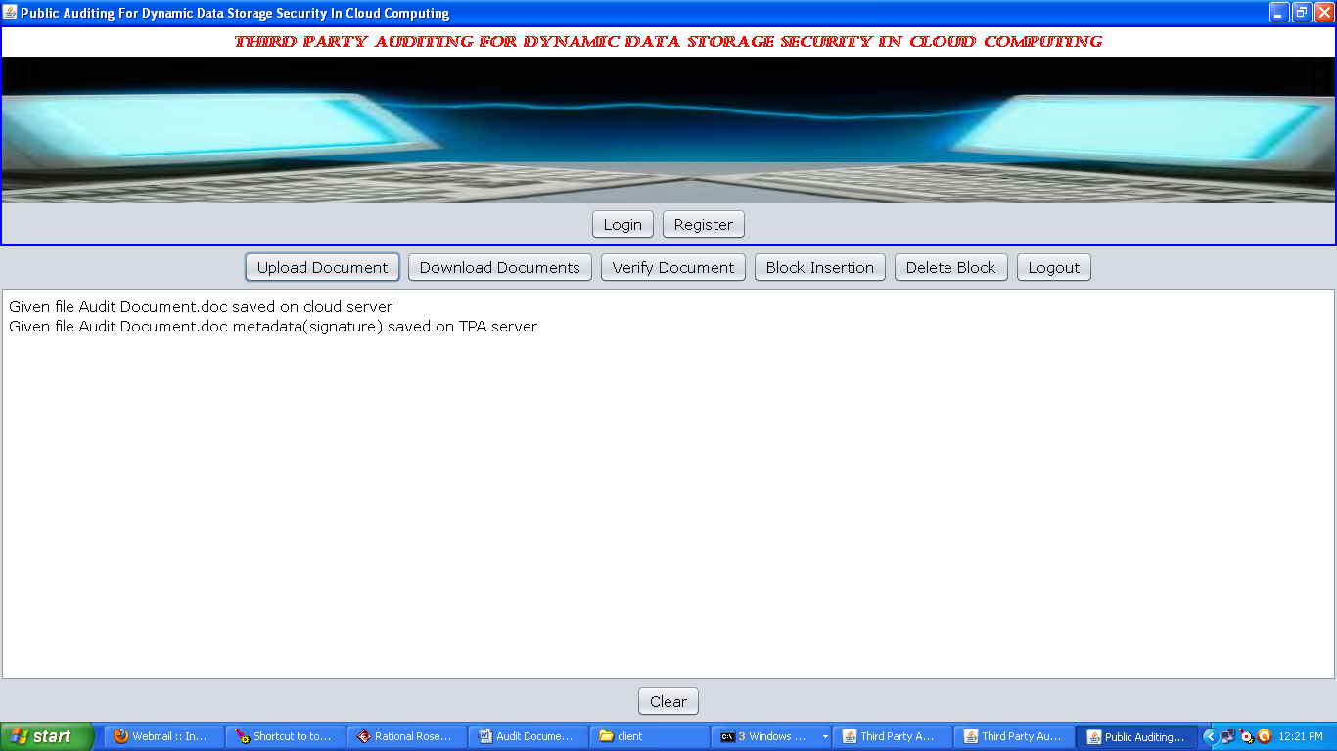

Fig 7.8 After Upload Client Page

The below screen is displayed when the download document button is clicked here user can download the documents which were stored by him previously into the cloud space.

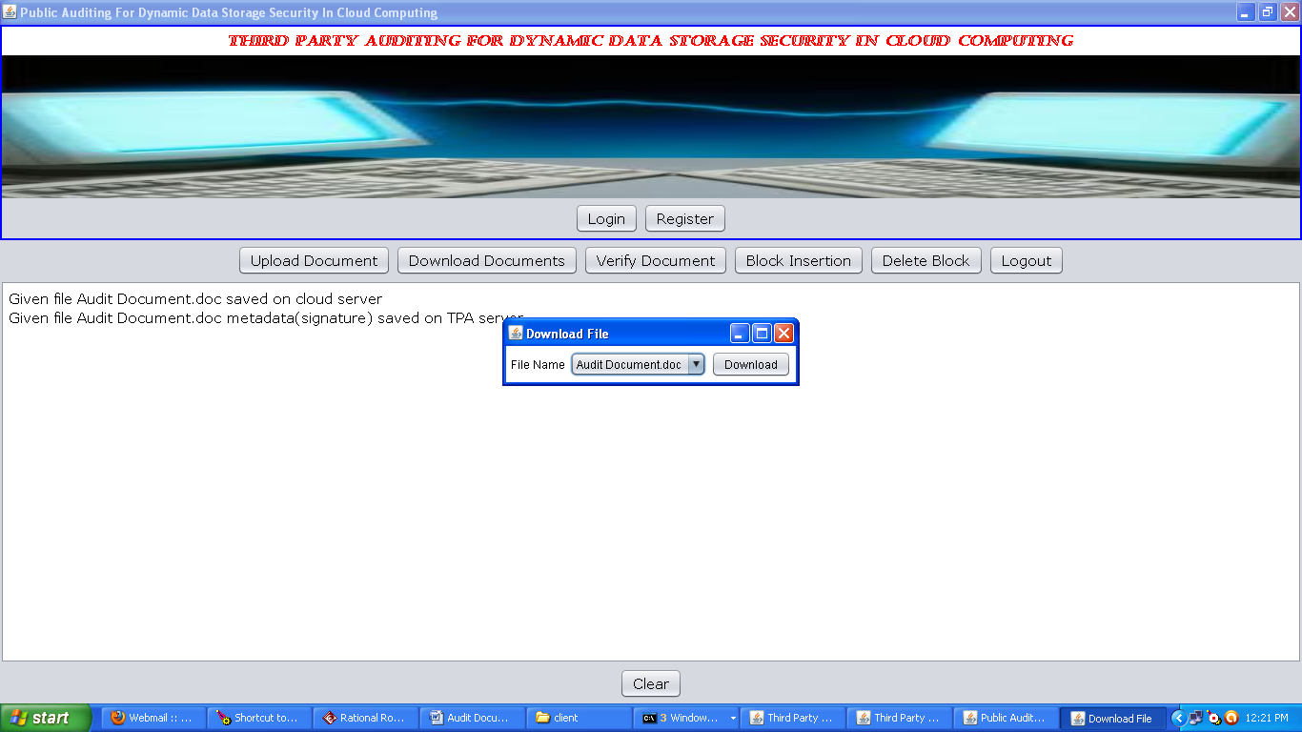

Fig 7.9 Download Page

The below is displayed when user want to insert block of file to the already stored file in the cloud this is possible by selecting a previously stored file in the cloud.

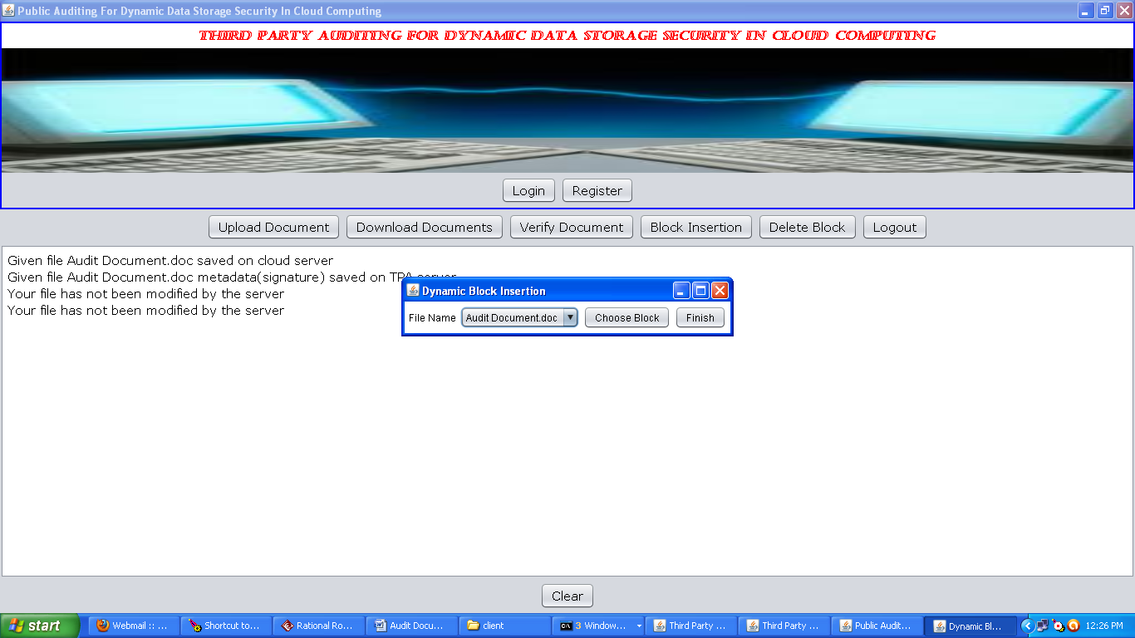

Fig 7.10 Block Insertion

The below is displayed when user want to insert block of file to the already stored file in the cloud this is possible by selecting a previously stored file in the cloud and by clicking on the choose block button user can browse the file from the system and insert to the particular chosen file.



Fig 7.11 Select the Block Of File To Insert

The below is displayed when user want to delete block of file from the already stored file in the cloud this is possible by selecting a previously stored file in the cloud. Whenever a file is selected list of blocks of the file are displayed.

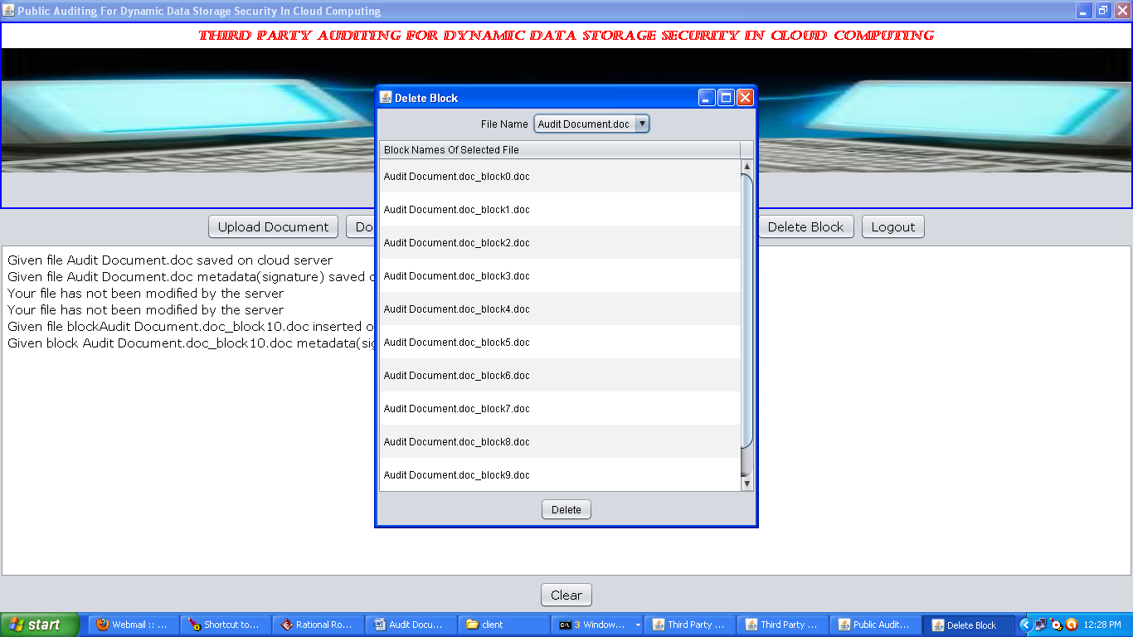

Fig 7.12 Delete the Block

The below is displayed when user want to delete block of file from the already stored file in the cloud this is possible by selecting a previously stored file in the cloud. Whenever a file is selected list of blocks of the file are displayed. We can select a particular block of file to be deleted.

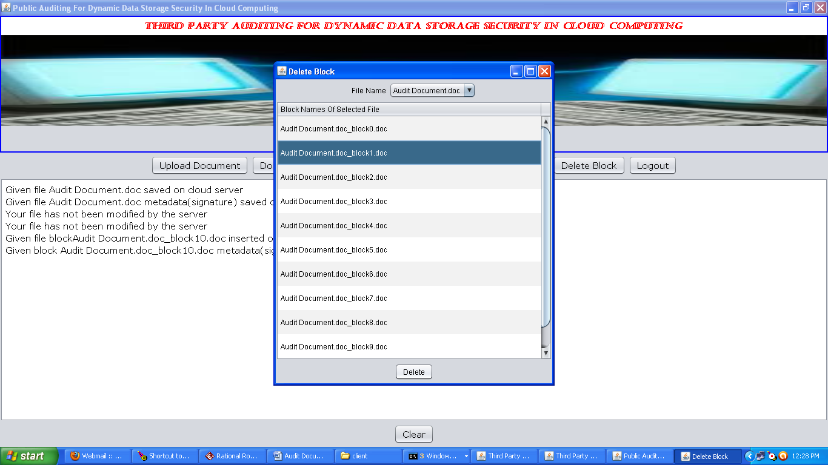

Fig 7.13 Select the Block to Delete

The below is displayed when user want to delete block of file from the already stored file in the cloud this is possible by selecting a previously stored file in the cloud. Whenever a file is selected list of blocks of the file are displayed. We can select a particular block of file to be deleted. By clicking on the delete button we can delete selected block of file.

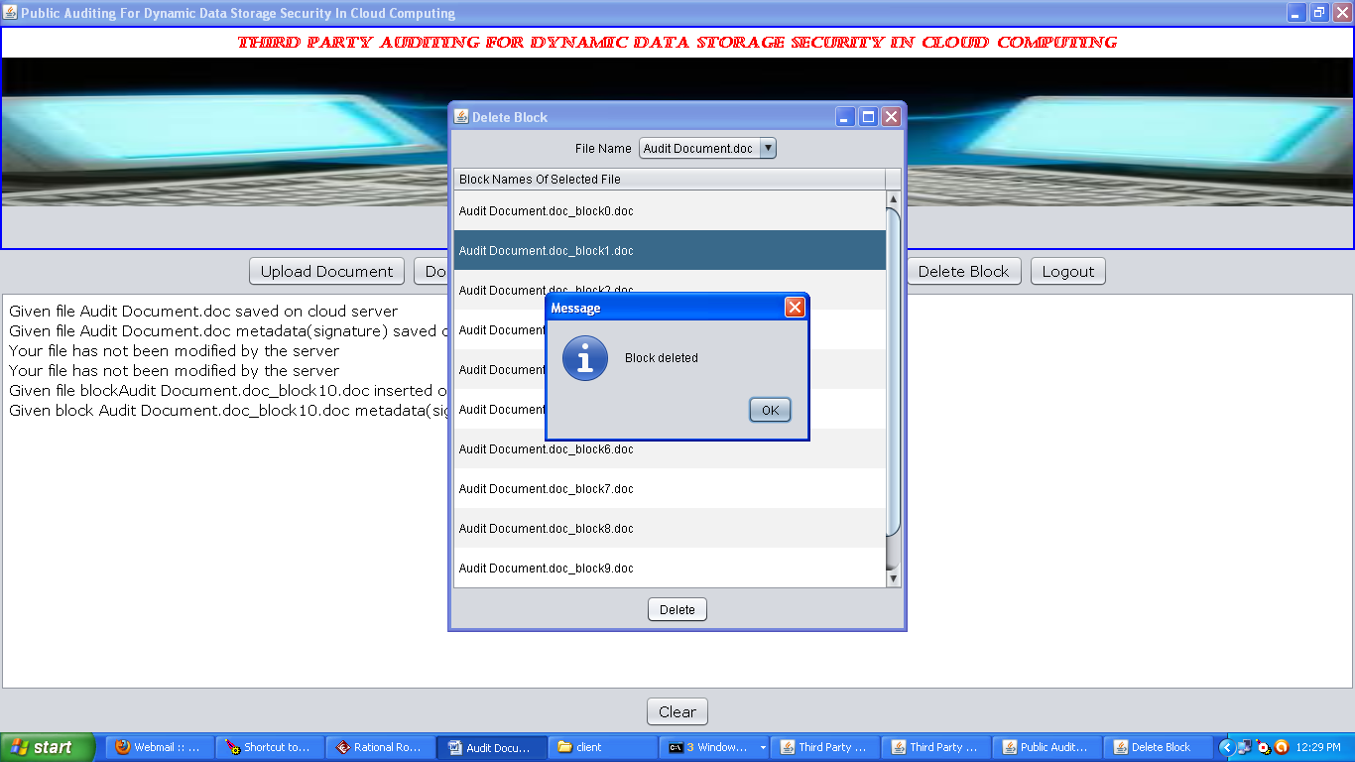

Fig 7.14 Block Deleted

The below screen is displayed when user clicks on verify document button. When user clicks on verify document button the list of files that are previously stored by the client will be displayed client can select the file which he want to verify and click on verify button.

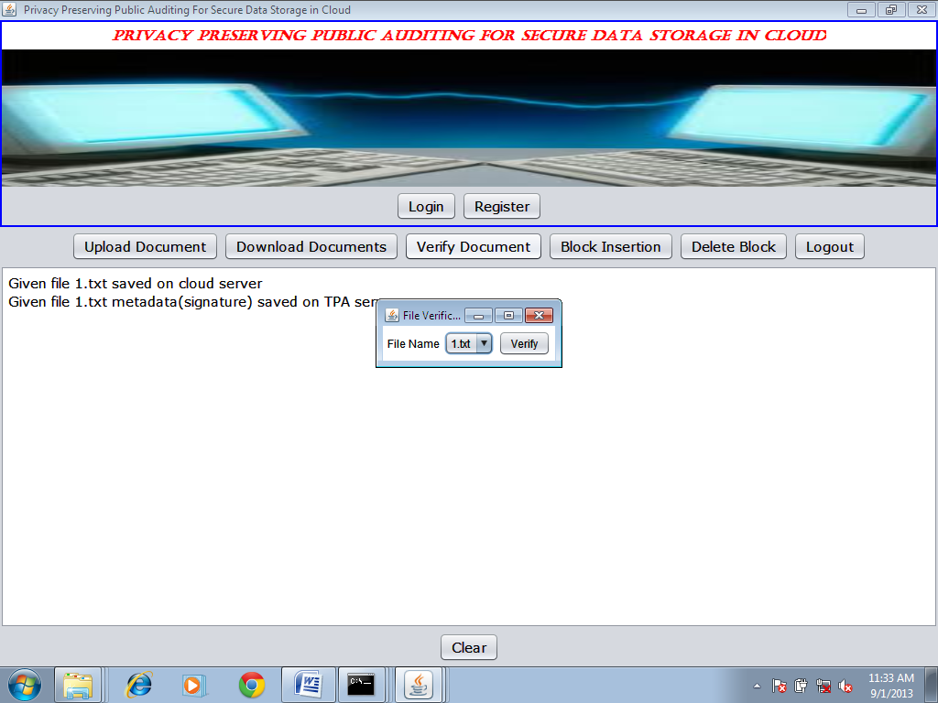

Fig 7.15 Verify Document

The below screen is displayed when user clicks on verify document button. When user clicks on verify document button the list of files that are previously stored by the client will be displayed client can select the file which he want to verify and click on verify button. When user clicks on verify button message will be displayed whether the file modified or not as shown in the below figure.

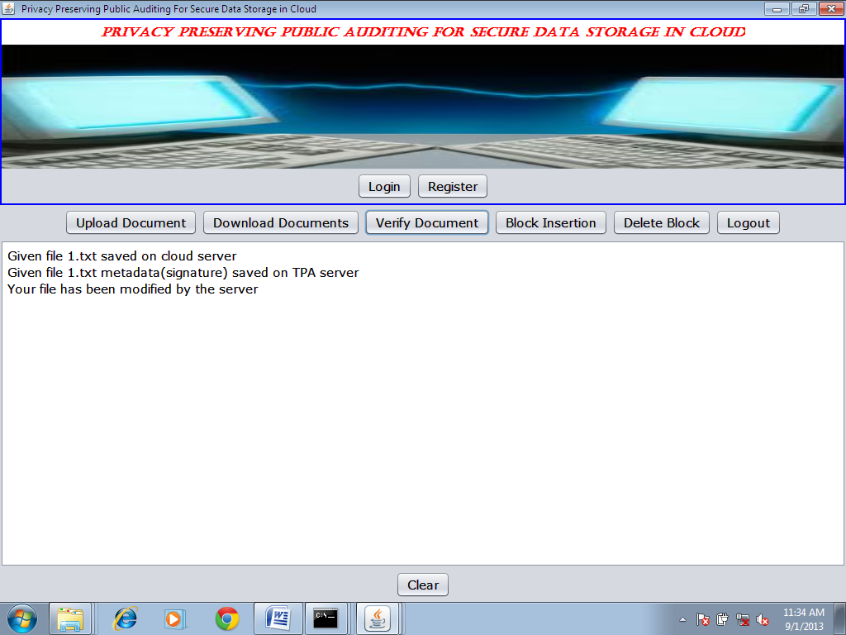

Fig 7.16 Verification Message After File Verification

The below screen displays the client logout whenever client clicks on the logout button the client comes out from his home page.

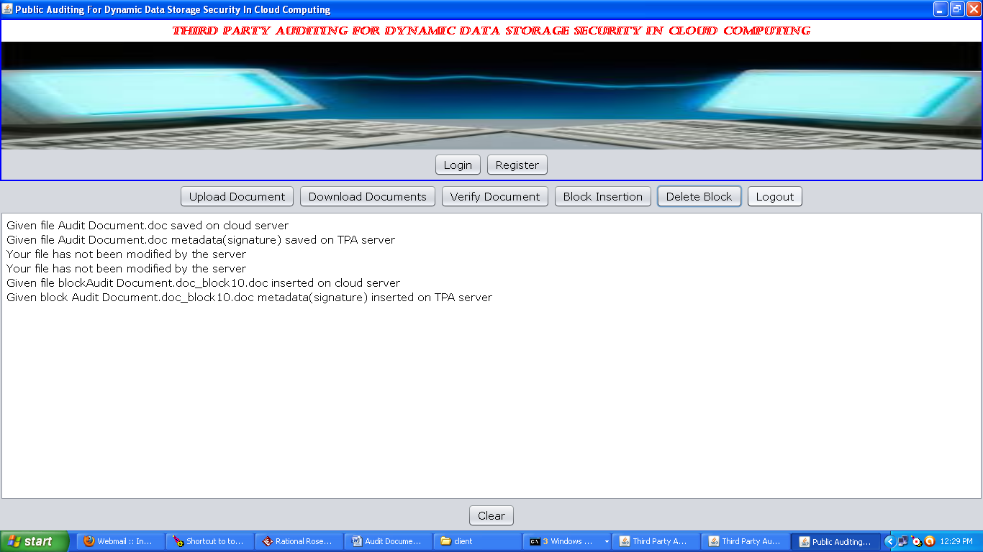

Fig 7.17 Client LogOut

The below screen shows the TPA after all the operations of the ser like uploading the documents, downloading the documents, verifying the documents, block insertion, block deletion, logout.

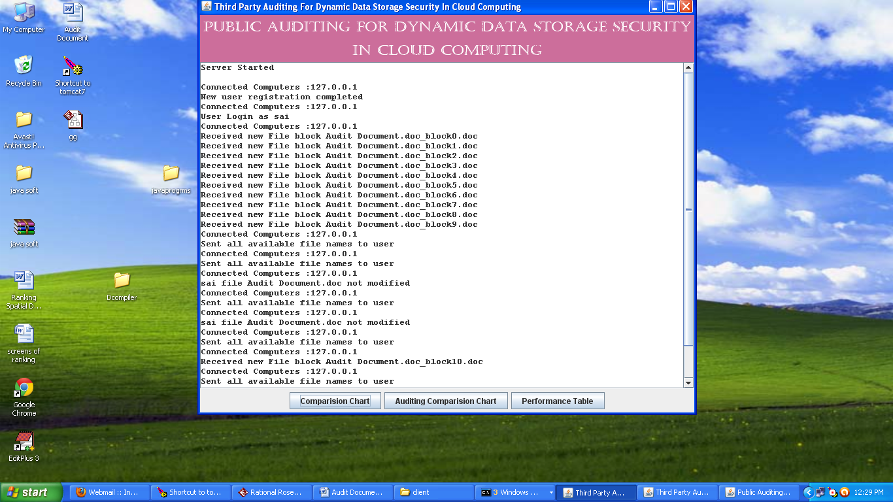

Fig 7.18 TPA after all the Operation

The below screen shows the Server after all the operations of the ser like uploading the documents, downloading the documents, verifying the documents, block insertion, block deletion, logout.

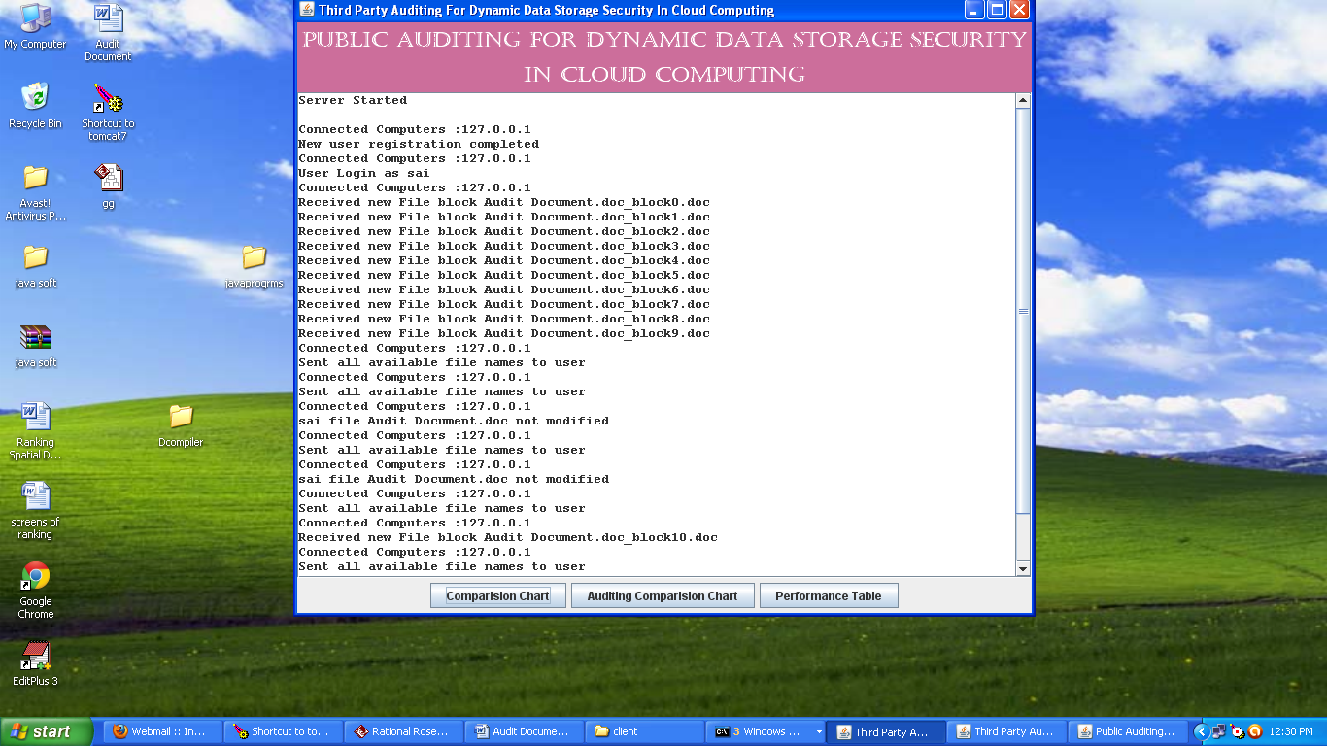

Fig 7.19 Server after all the Operation

The below screen shows the comparison chart for the clients here the average auditing time for the clients is calculated and displayed in the form of chart.

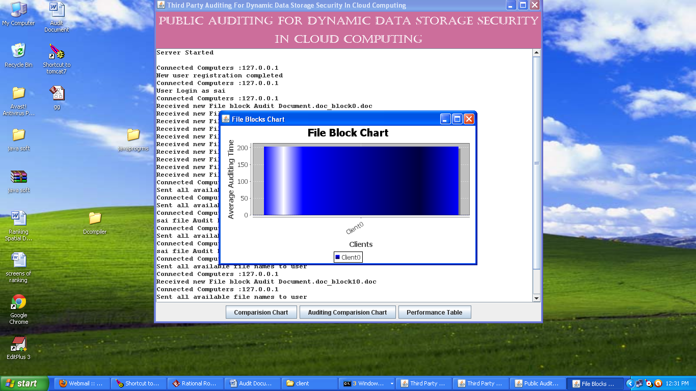

Fig 7.20 Time Comparison Graph

The below screen shows the comparison chart for the blocks here the average auditing time for the blocks is calculated and displayed in the form of chart.

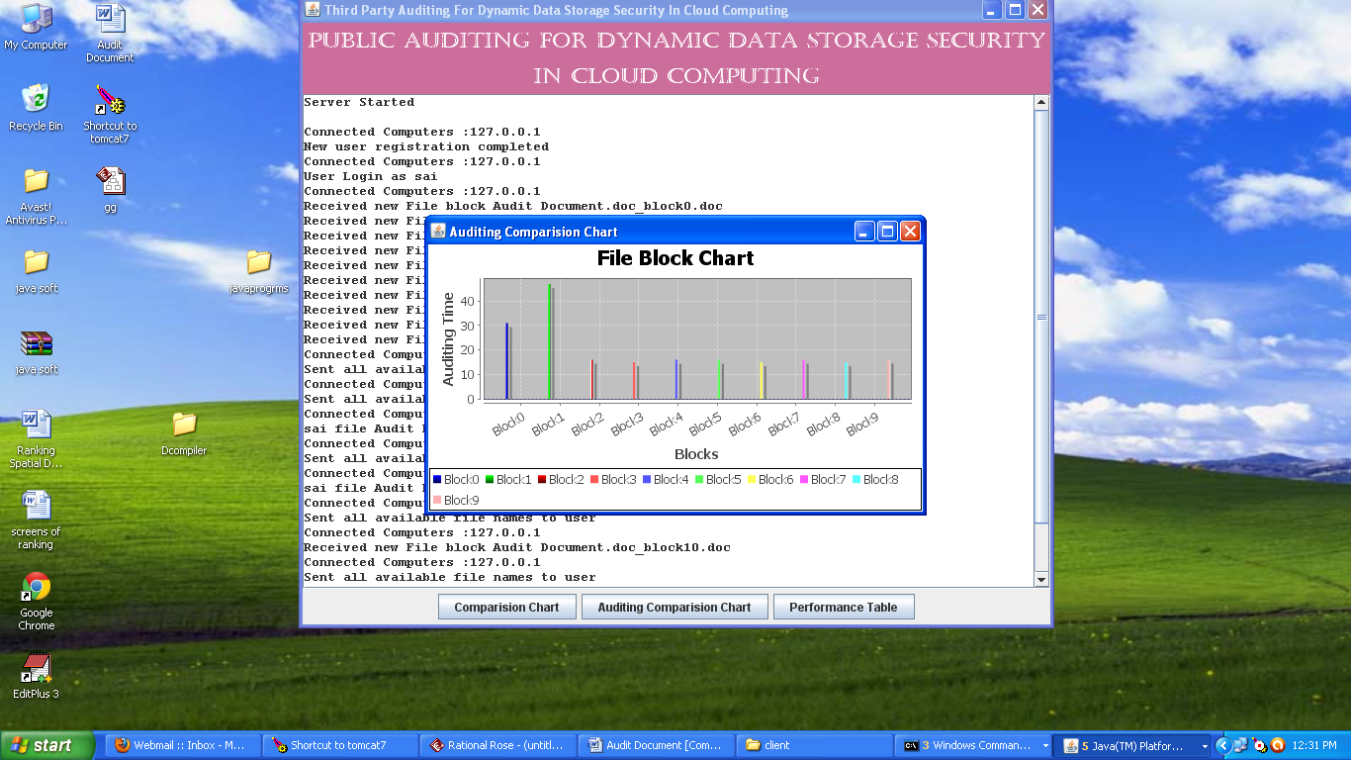

Fig 7.21 Audit Comparison Chart

The below screen shows the performance table the fields in the table are server comparison time, verifier comparison time.

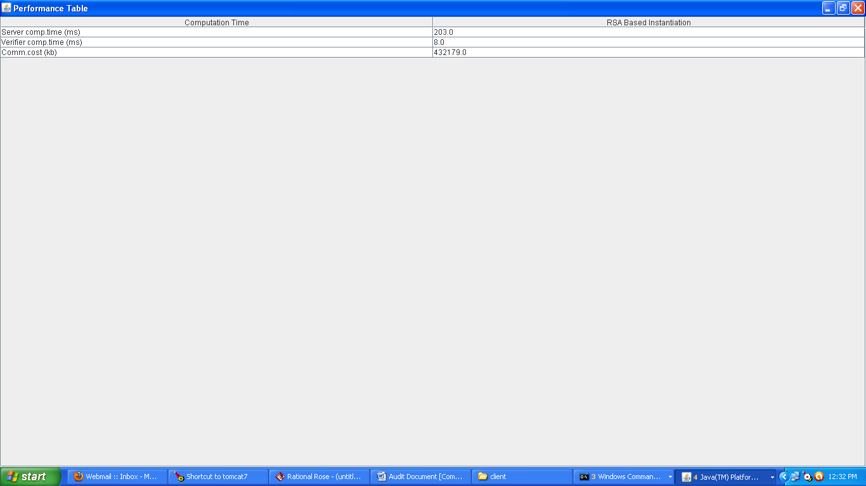

Fig 7.22 Performance Table

**8. CONCLUSION AND FUTURE SCOPE**

**8.1. CONCLUSION**

In this project, we propose a privacy-preserving public auditing system for data storage security in Cloud Computing. We utilize the homomorphic linear authenticator and random masking to guarantee that the TPA would not learn any knowledge about the data content stored on the cloud server during the efficient auditing process, which not only eliminates the burden of cloud user from the tedious and possibly expensive auditing task, but also alleviates the users’ fear of their outsourced data leakage. Considering TPA may concurrently handle multiple audit sessions from different users for their outsourced data files, we further extend our privacy preserving public auditing protocol into a multi-user setting, where the TPA can perform multiple auditing tasks in a batch manner for better efficiency. Extensive analysis shows that our schemes are provably secure and highly efficient.

**9. FUTURE ENHANCEMENT**

**9.1. FUTURE SCOPE**

Our preliminary experiment conducted on Amazon EC2 instance further demonstrates the fast performance of our design on both the cloud and the auditor side. We leave the full-fledged implementation of the mechanism on commercial public cloud as an important future extension, which is expected to robustly cope with very large scale data and thus encourage users to adopt cloud storage services more confidently.

**10. BIBLIOGRAPHY**

[1.] C. Wang, Q. Wang, K. Ren, and W. Lou, “Privacy-Preserving Public Auditing for Storage Security in Cloud Computing,” Proc. IEEE INFOCOM ’10, Mar. 2010.

[2.] P. Mell and T. Grance, “Draft NIST Working Definition of Cloud Computing,” http://csrc.nist.gov/groups/SNS/cloudcomputing/ index.html, June 2009.

[3.] M. Armbrust, A. Fox, R. Griffith, A.D. Joseph, R.H. Katz, A. Konwinski, G. Lee, D.A. Patterson, A. Rabkin, I. Stoica, and M. Zaharia, “Above the Clouds: A Berkeley View of Cloud Computing,” Technical Report UCB-EECS-2009-28, Univ. of California, Berkeley, Feb. 2009.

[4.] Cloud Security Alliance, “Top Threats to Cloud Computing,” http://www.cloudsecurityalliance.org, 2010.

[5.] M. Arrington, “Gmail Disaster: Reports of Mass Email Deletions,” http://www.techcrunch.com/2006/12/28/gmail-disasterreportsof- mass-email-deletions/, 2006.

[6.]J.Kincaid,“MediaMax/TheLinkupClosesItsDoors,”http://www.techcrunch.com/2008/07/10/mediamaxthelinkup-closesits- doors/, July 2008.

[7.] Amazon.com, “Amazon s3 Availability Event: July 20, 2008,” http://status.aws.amazon.com/s3-20080720.html, July 2008.

[8.] Q. Wang, C. Wang, K. Ren, W. Lou, and J. Li, “Enabling Public Auditability and Data Dynamics for Storage Security in Cloud Computing,” IEEE Trans. Parallel and Distributed Systems, vol. 22, no. 5, pp. 847-859, May 2011.

[9.] G. Ateniese, R. Burns, R. Curtmola, J. Herring, L. Kissner, Z. Peterson, and D. Song, “Provable Data Possession at Untrusted Stores,” Proc. 14th ACM Conf. Computer and Comm. Security (CCS ’07), pp. 598-609, 2007.

[10.] M.A. Shah, R. Swaminathan, and M. Baker, “Privacy-Preserving Audit and Extraction of Digital Contents,” Cryptology ePrint Archive, Report 2008/186, 2008.

[11.] A. Juels and J. Burton, S. Kaliski, “PORs: Proofs of Retrievability for Large Files,” Proc. ACM Conf. Computer and Comm. Security (CCS ’07), pp. 584-597, Oct. 2007.

[12.] Cloud Security Alliance, “Security Guidance for Critical Areas of Focus in Cloud Computing,” http://www.cloudsecurityalliance. org, 2009.

[13.] H. Shacham and B. Waters, “Compact Proofs of Retrievability,” Proc. Int’l Conf. Theory and Application of Cryptology and Information Security: Advances in Cryptology (Asiacrypt), vol. 5350, pp. 90-107, Dec. 2008.

[14.] C. Wang, K. Ren, W. Lou, and J. Li, “Towards Publicly Auditable Secure Cloud Data Storage Services,” IEEE Network Magazine, vol. 24, no. 4, pp. 19-24, July/Aug. 2010.

[15.] M.A. Shah, M. Baker, J.C. Mogul, and R. Swaminathan, “Auditing to Keep Online Storage Services Honest,” Proc. 11th USENIX Workshop Hot Topics in Operating Systems (HotOS ’07), pp. 1-6, 2007.

[16.] 104th United States Congress, “Health Insurance Portability and Accountability Act of 1996 (HIPPA),” http://aspe.hhs.gov/ admnsimp/pl104191.htm, 1996.

[17.] R. Curtmola, O. Khan, and R. Burns, “Robust Remote Data Checking,” Proc. Fourth ACM Int’l Workshop Storage Security and Survivability (StorageSS ’08), pp. 63-68, 2008.

[18.] K.D. Bowers, A. Juels, and A. Oprea, “Proofs of Retrievability: Theory and Implementation,” Proc. ACM Workshop Cloud Computing Security (CCSW ’09), pp. 43-54, 2009.

[19.] D. Boneh, B. Lynn, and H. Shacham, “Short Signatures from the Weil Pairing,” J. Cryptology, vol. 17, no. 4, pp. 297-319, 2004.

[20.]. A.L. Ferrara, M. Green, S. Hohenberger, and M. Pedersen, “Practical Short Signature Batch Verification,” Proc. Cryptographers’ Track at the RSA Conf. 2009 on Topics in Cryptology (CT RSA), pp. 309-324, 2009.

[21.] G. Ateniese, R.D. Pietro, L.V. Mancini, and G. Tsudik, “Scalable and Efficient Provable Data Possession,” Proc. Int’l Conf. Security and Privacy in Comm. Networks (SecureComm ’08), pp. 1-10, 2008.

[22.] C. Wang, Q. Wang, K. Ren, and W. Lou, “Towards Secure and Dependable Storage Services in Cloud Computing,” IEEE Trans. Service Computing, vol. 5, no. 2, 220-232, Apr. June 2012.

[23.] C. Erway, A. Kupcu, C. Papamanthou, and R. Tamassia, “Dynamic Provable Data Possession,” Proc. ACM Conf. Computer and Comm. Security (CCS ’09), pp. 213-222, 2009.

[24] R.C. Merkle, “Protocols for Public Key Cryptosystems,” Proc. IEEE Symp. Security and Privacy, 1980.

[25.] G. Ateniese, S. Kamara, and J. Katz, “Proofs of Storage from Homomorphic Identification Protocols,” Proc. 15th Int’l Conf. Theory and Application of Cryptology and Information Security: Advances in Cryptology (ASIACRYPT), pp. 319-333, 2009.

[26.] M. Bellare and G. Neven, “Multi-Signatures in the Plain Public- Key Model and a General Forking Lemma,” Proc. ACM Conf. Computer and Comm. Security (CCS), pp. 390-399, 2006.

[27.] Amazon.com, “Amazon Elastic Compute Cloud,” http://aws. amazon.com/ec2/, 2009.

[28.] Y. Zhu, H. Wang, Z. Hu, G.-J. Ahn, H. Hu, and S. Yau, “Efficient Provable Data Possession for Hybrid Clouds,” Cryptology ePrint Archive, Report 2010/234, 2010.

[29.] Y. Dodis, S.P. Vadhan, and D. Wichs, “Proofs of Retrievability via Hardness Amplification,” Proc. Theory of Cryptography Conf. Theory of Cryptography (TCC), pp. 109 127, 2009.

[30.] F. Sebe, J. Domingo-Ferrer, A. Martı´nez-Balleste, Y. Deswarte, and J.-J. Quisquater, “Efficient Remote Data Possession Checking in Critical Information Infrastructures,” IEEE Trans. Knowledge and Data Eng., vol. 20, no. 8, pp. 1034-1038, Aug. 2008.

[31.] T. Schwarz and E.L. Miller, “Store, Forget, and Check: Using Algebraic Signatures to Check Remotely Administered Storage,” Proc. IEEE Int’l Conf. Distributed Computing Systems (ICDCS ’06), 2006.

[32.] R. Curtmola, O. Khan, R. Burns, and G. Ateniese, “MR-PDP: Multiple-Replica Provable Data Possession,” Proc. IEEE Int’l Conf. Distributed Computing Systems (ICDCS ’08), pp. 411 420, 2008.

[33.] K.D. Bowers, A. Juels, and A. Oprea, “HAIL: A High-Availability and Integrity Layer for Cloud Storage,” Proc. ACM Conf. Computer and Comm. Security (CCS ’09), pp. 187-198, 2009.